#include <iostream>
#include <fstream>
#include <vector>
using namespace std;

// Crop structure
struct Crop {
string name;
string season;
string soil;
string nutrient; // add / deplete
};

// Function to add crop to file
void addCrop() {
ofstream file("crops.txt", ios::app);

Crop c;
cout << "\nEnter crop name: ";
cin >> c.name;
cout << "Enter season (Kharif/Rabi/Summer): ";
cin >> c.season;
cout << "Enter soil type (Loamy/Clay/Sandy): ";
cin >> c.soil;
cout << "Nutrient effect (add/deplete): ";
cin >> c.nutrient;

file << c.name << " " << c.season << " " << c.soil << " " << c.nutrient << endl;
file.close();

cout << "✅ Crop added successfully!\n";
}

// Function to display crops
void viewCrops() {
ifstream file("crops.txt");

Crop c;
cout << "\n--- Crop Database ---\n";

while (file >> c.name >> c.season >> c.soil >> c.nutrient) {
cout << "Name: " << c.name
<< ", Season: " << c.season
<< ", Soil: " << c.soil
<< ", Nutrient: " << c.nutrient << endl;
}

file.close();
}

// Function to recommend crop
void recommendCrop() {
ifstream file("crops.txt");
vector<Crop> crops;

Crop c;

// Load data into vector
while (file >> c.name >> c.season >> c.soil >> c.nutrient) {
crops.push_back(c);
}
file.close();

string prevCrop, soil, season;
string prevNutrient = "";

cout << "\nEnter previous crop: ";
cin >> prevCrop;
cout << "Enter soil type: ";
cin >> soil;
cout << "Enter season: ";
cin >> season;

// Find previous crop nutrient effect
for (auto &crop : crops) {
if (crop.name == prevCrop) {
prevNutrient = crop.nutrient;
break;
}
}

cout << "\n🌱 Recommended Crops:\n";

bool found = false;

for (auto &crop : crops) {
if (crop.soil == soil && crop.season == season && crop.name != prevCrop) {

// Rotation logic
if (prevNutrient == "deplete" && crop.nutrient == "add") {
cout << "✔ " << crop.name << " (Restores nutrients)\n";
found = true;
}
else if (prevNutrient == "add" && crop.nutrient == "deplete") {
cout << "✔ " << crop.name << " (Balanced rotation)\n";
found = true;
}
}
}

if (!found) {
cout << "⚠ No exact match found. Try different inputs.\n";
}
}

// Main menu
int main() {
int choice;

do {
cout << "\n===== 🌾 Crop Rotation Scheduler =====\n";
cout << "1. Add Crop\n";
cout << "2. View Crops\n";
cout << "3. Get Recommendation\n";
cout << "4. Exit\n";
cout << "Enter your choice: ";
cin >> choice;

switch (choice) {
case 1: addCrop(); break;
case 2: viewCrops(); break;
case 3: recommendCrop(); break;
case 4: cout << "Exiting...\n"; break;
default: cout << "Invalid choice!\n";
}

} while (choice != 4);

return 0;
}
OUTPUT:-
STEP1:-
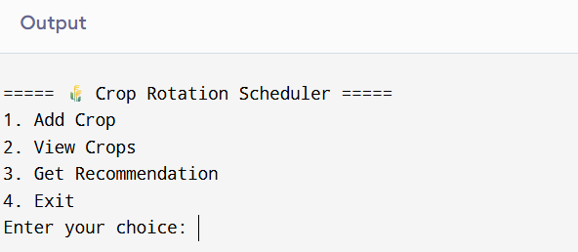
STEP-2:-
